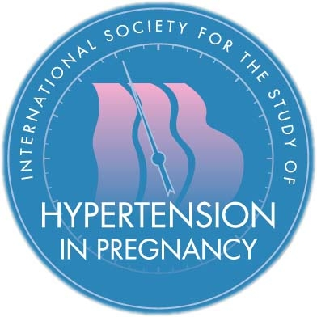
The XXII World Congress of the International Society for the Study of Hypertension in Pregnancy

- Name of Endorsing ISSHP Council Member:

- Proposed host country and city:

- Proposed conference venue (if known):

- If you are submitting in partnership with a Conference Organiser, please identify the company:

- Please outline the benefits of your proposed host country and city. Please pay particular emphasis on accessibility for international travellers and additional attractions. If your proposed host country has hosted a World Congress in the last 20 years, please explain why a return visit is recommended. If you have identified a conference venue please describe it. If you have not identified a conference venue please briefly describe potential venues (1000 words max).

- World Congress must run at no cost to the Society. We particularly wish to encourage clinicians and scientists in training and colleagues from low resource settings to attend Congress. This is made more achievable by sponsorship. Please describe the potential for raising sponsorship for Congress and detail sources and potential amounts (750 words max).

- Please describe an indicative budget per delegate for registration and a 4-night hotel stay in your proposed host venue. Please also provide details of accommodation nearby to suit a wide range of budgets (750 words max).

- Please indicate the membership of the local scientific organizing committee. This should consist of 5-10 scientists and clinicians working in the host country with a track-record in hypertensive conditions of pregnancy. This committee must be chaired by a Principal Investigator and this application must be accompanied by their detailed CV.

